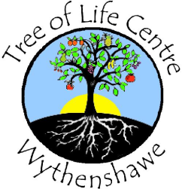
Tree of Life Centre Wythenshawe
Greenbrow Road
Newall Green
Wythenshawe
Manchester
M23 2UE

0161 489 7018
info@treeoflifecentre.org.uk

Volunteer Role
Role : Small Goods Assistant
Duties :
- Ensure that there are sufficient items on sale and where necessary obtain additional items from sorted stock and display
- Check items are neatly presented and sorted
- Ensure items are clean
- Assist customers
- Ensure areas are clean and tidy

Equipment required :

- Tree of Life Centre identification badge
- Safety Shoes

Experienced preferred :

- Manual handling of small items of stock
- Customer service type environment

Hours of Duties :

- Monday 9:30am – 3:30pm (9:30am – 12.30pm or 12.30 – 3pm)
- Tuesday 9:30am – 3:30pm (9:30am – 12.30pm or 12.30 – 3pm)
- Wednesday 9:30am – 3:30pm (9:30am – 12.30pm or 12.30 – 3pm)
- Thursday 9:30am – 3:30pm (9:30am – 12.30pm or 12.30 – 3pm)

